# Tangents – Lines Making Curves

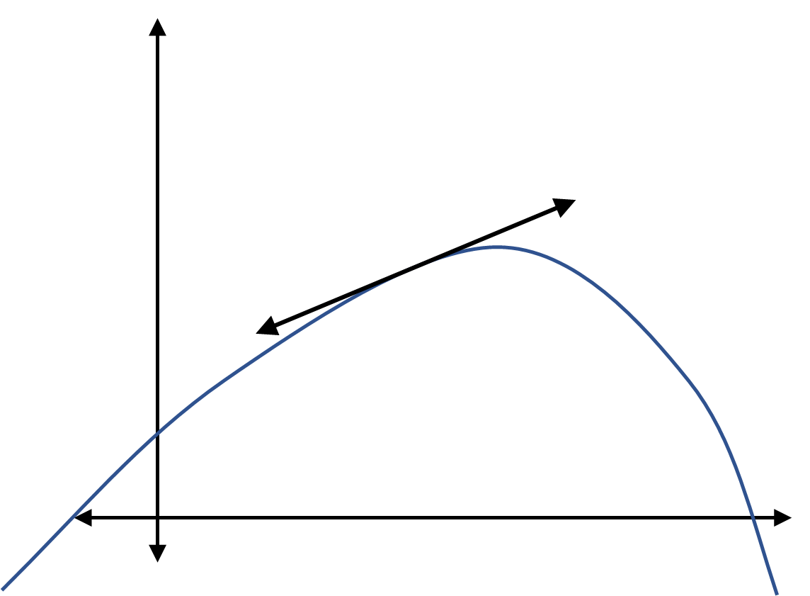****Tangent – a line that touches the surface of a curve once in the direction of a curve.

Graph 1

Graph 1 shows a tangent to a curve that:

* Touches the curve
* Touches the curve only once
* Goes in the direction of the curve

If you zoom in far enough on any curve, it looks like a straight line.

Take two points on a curve and move them closer and closer together. The line between the two of them approaches closer and closer to the tangent line. (*See pictures below*)

|  |  |
| --- | --- |
|  |  |
|  |  |

Since the distance between the points approaches zero for accuracy, **a limit can find the tangent line**.

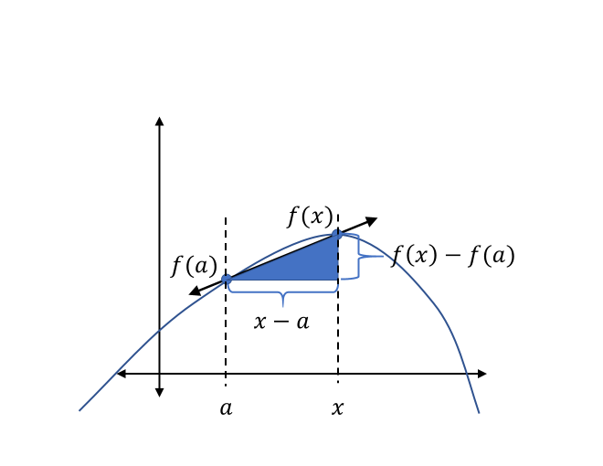A **triangle** shows the tangent line. (Graph 2)

Graph 2

Since the distance between $a$ and $x$ should approach zero, the **tangent line’s slope is the triangle’s slope**.

$$\lim_{x→a}{\frac{f\left(x\right)-f\left(a\right)}{x-a}}=m$$

**Remember**, $m$ is the variable for slope.

Restating the triangle definition above, if $h$ is the width of the triangle,

$$m=\lim_{h→0}{\frac{f\left(x\right)-f\left(x-h\right)}{h}}$$

# Derivatives – Rates of Change

Derivative – the measure of how a function’s output changes as its input changes.

The **tangent line is not the same** across a curve (except for a line). This means that one variable ($m$) cannot be *the* way to know the tangent of the curve at every point on the curve. The **derivative is like the tangent** (or slope) of the function at every point.

The derivative of any function $f(a)$ is another function, $f^{'}\left(a\right)$.

f’(a) is pronounced “eff-tick of ey.”

Derivatives measure **rates of change** – how much does the function’s output change compared to how much the function’s input changes, at a given point.

“Rate of …” 🡺 “fraction”

“Change” 🡺 “”

“output change compared to…input change” 🡺

Since the input is $x$ and the output is $y$, $\frac{change of output}{change of input}=\frac{Δy}{Δx}$.

“at a given point” 🡺 “there’s some variable $a$”

How can the fraction $\frac{change of output}{change of input}$ be written? Suppose the function and sample point is $f(a)$. Also, like the definition for tangents above, set a variable $h$ to approach zero, to create an imaginary triangle.

🡺

🡺

🡺

Simplifying everything above, $f^{'}\left(a\right)=\lim_{h→0}{\frac{f\left(a+h\right)-f\left(a\right)}{h}}$.

# Velocity – Derivatives of Position

Velocity – speed with direction.

When objects move, usually their velocity changes. The **velocity does not remain constant** when an object speeds up or slows down or changes direction.

Instantaneous Velocity – the velocity at one precise moment in time.

Because velocity measures how the position changes as time changes, velocity is the derivative of position over time.